

1. Devesh Soni

Secretary

8769778068

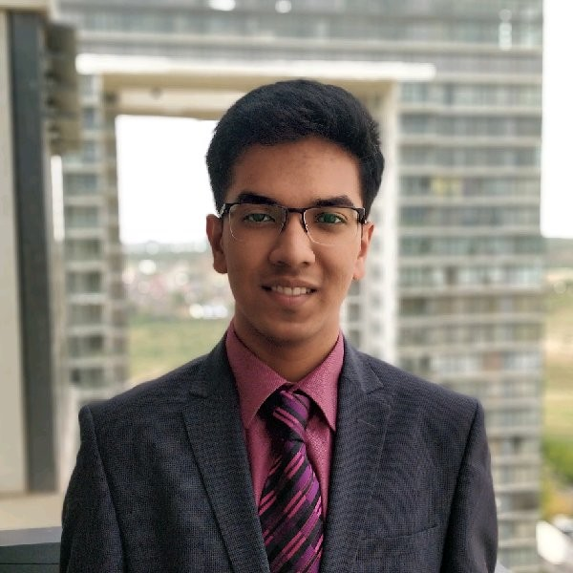

2. Utkarsh Aggarwal

Consulting Head

9176612180

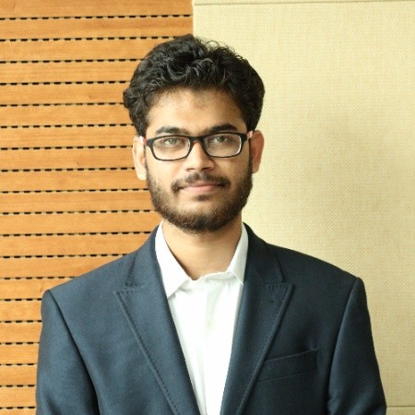

3. Mithilesh Kohale

Analytics Head

8830285891

4. Manav Agarwal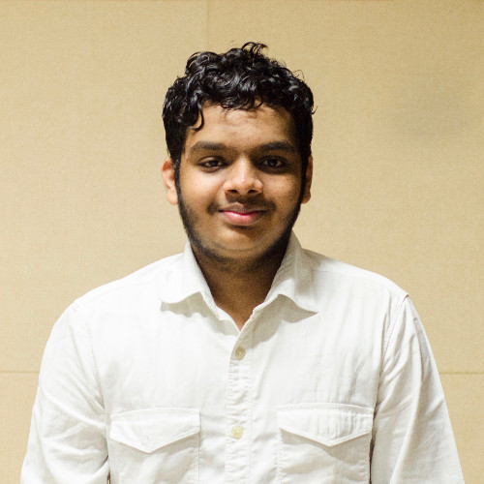

Events Manager

9957991661

**Alumni**

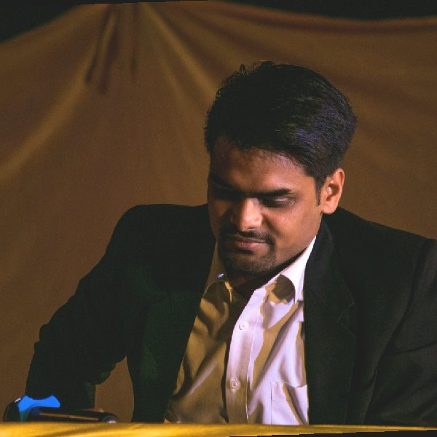

1. **Tushar Garg**

**Worked at BCG, Exl**

**Currently at IIM Bangalore**

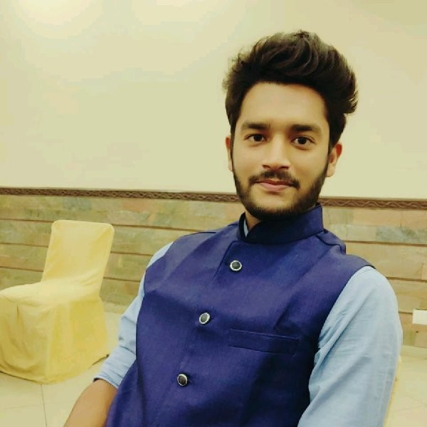

1. **Harshit Singh**

**Working at Datametica**

1. **Shaswat Srivastava**

**Working at Rivigo**